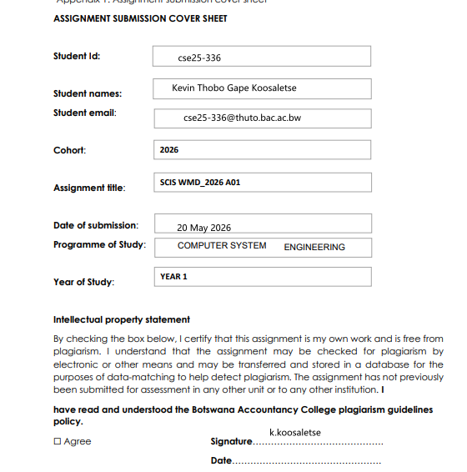

PAGE TEMPLATE DESIGN
HOME PAGE
Home page is the first page that appears when opening the website.
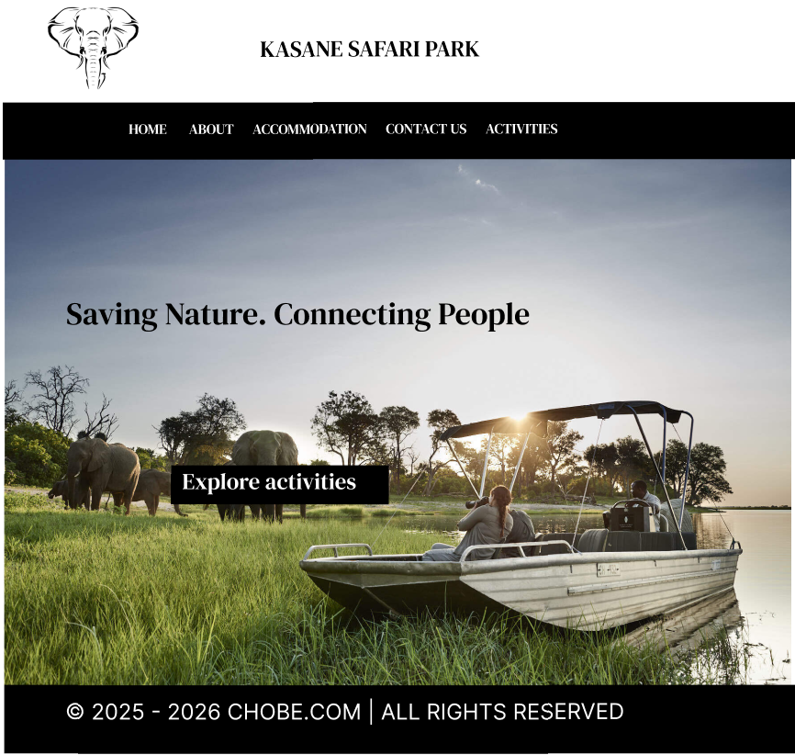

This is the page that appears when the activities button in the navigation is clicked to show the user what activities Kasane has to offer for them. 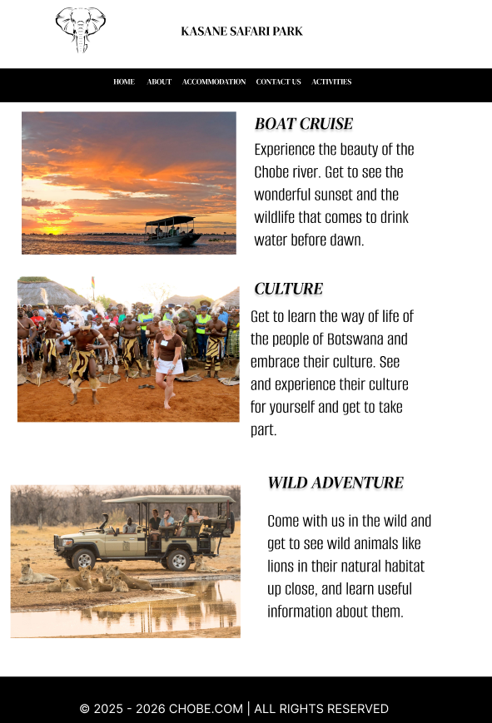

This is the accomodation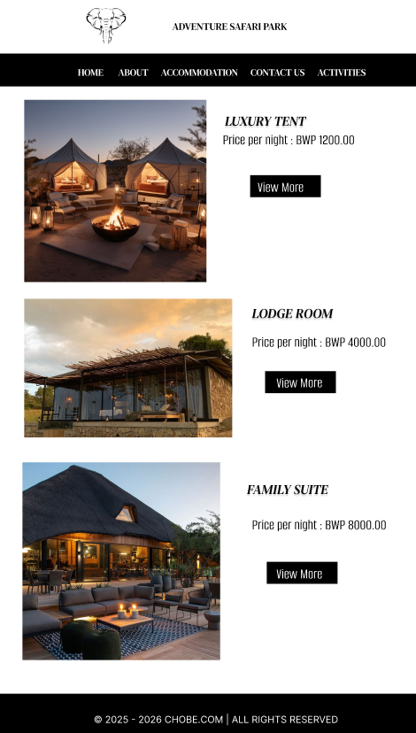

CONTACT PAGE LAYOUT
This is the page that shows the contact details of the user can communicate with the website team.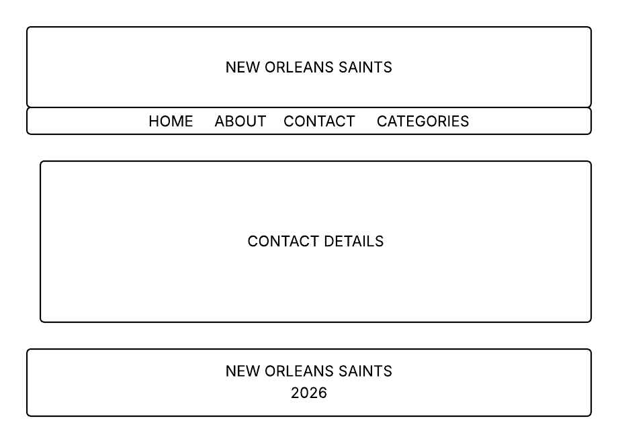

ABOUT PAGE LAYOUT
This is the About page layout that shows what the website is about and what it does.
